Preliminary Research into Student Evaluations of Teacher Effectiveness
Focus on Writing/Grammar

Research on student evaluations of teacher performance (Perry and Smart, 2007) shows these sources of student bias:
- Student evaluations of teachers tend to be stable, and have been found to reveal information about the teacher's effectiveness, not the course
- Students tend to rate more difficult classes higher than easier classes
- Students rate courses/teachers higher when they find the material interesting
- If the teacher is in the room, the students tend to give the teacher higher evaluations
- Students give teachers lower evaluations if they do not provide timely feedback

Results of the EPI Student Course Survey show:
- Students in levels BW-3 consider RV to be the most difficult course
- Least favorite course for levels BW-3 is relatively equal
- Students in levels 4-6 consider WG to be the most difficult course
- 54% of students in levels 4-6 rate WG as their least favorite course
- Students in levels 4-6 rate SL as the easiest course
- The data shows that those who rated WG as their most difficult course also rated it as their least favorite (70%)

Perry, R. P. and Smart, J. C. (Eds.). (2007). The Scholarship of Teaching and Learning in Higher Education: An Evidence-Based Perspective. Oxford, UK: Springer. p319-383.
Favorite Course Summary Report: Levels BW-3
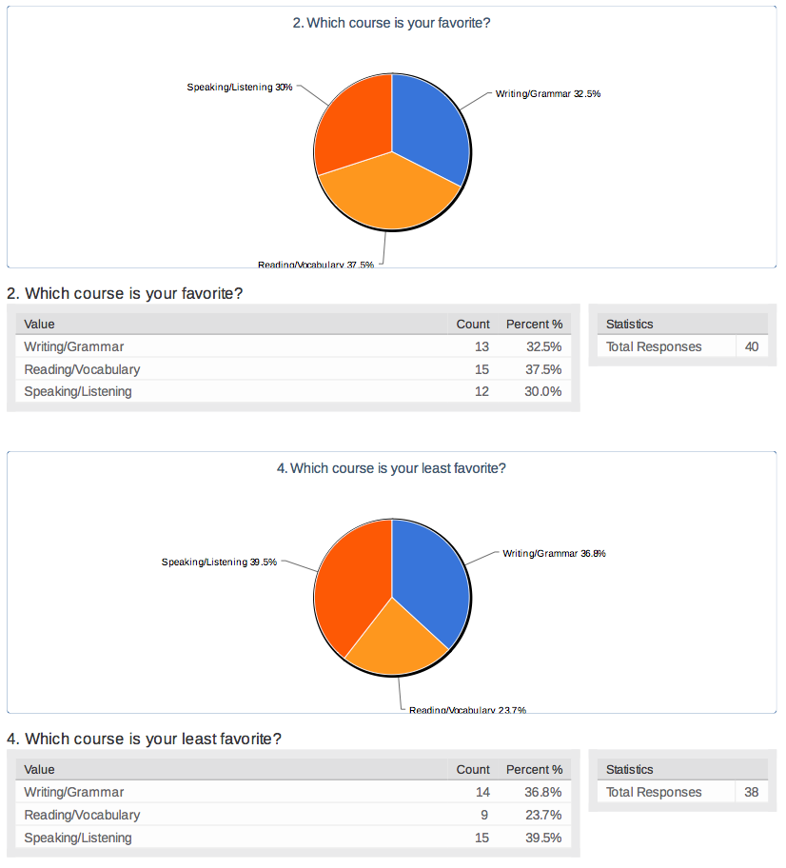

Favorite Course Summary Report: Levels 4-6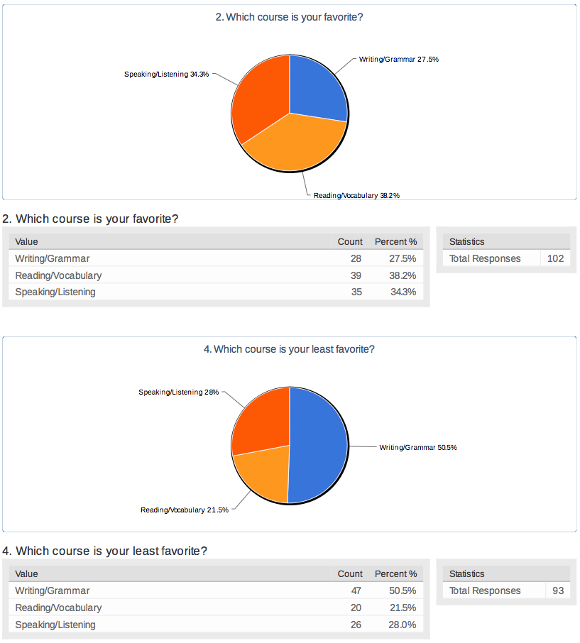

Easy/Difficult Course Summary Report: Levels BW-3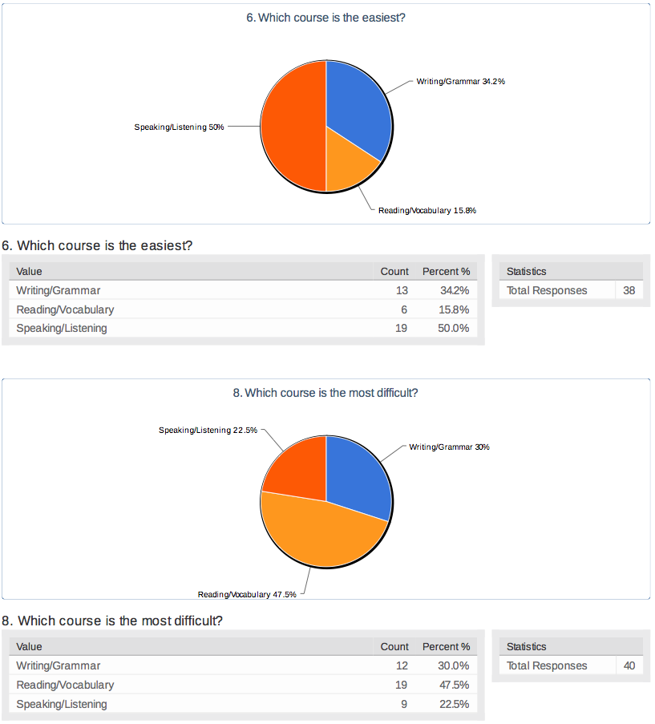

Easy/Difficult Course Summary Report: Levels 4-6
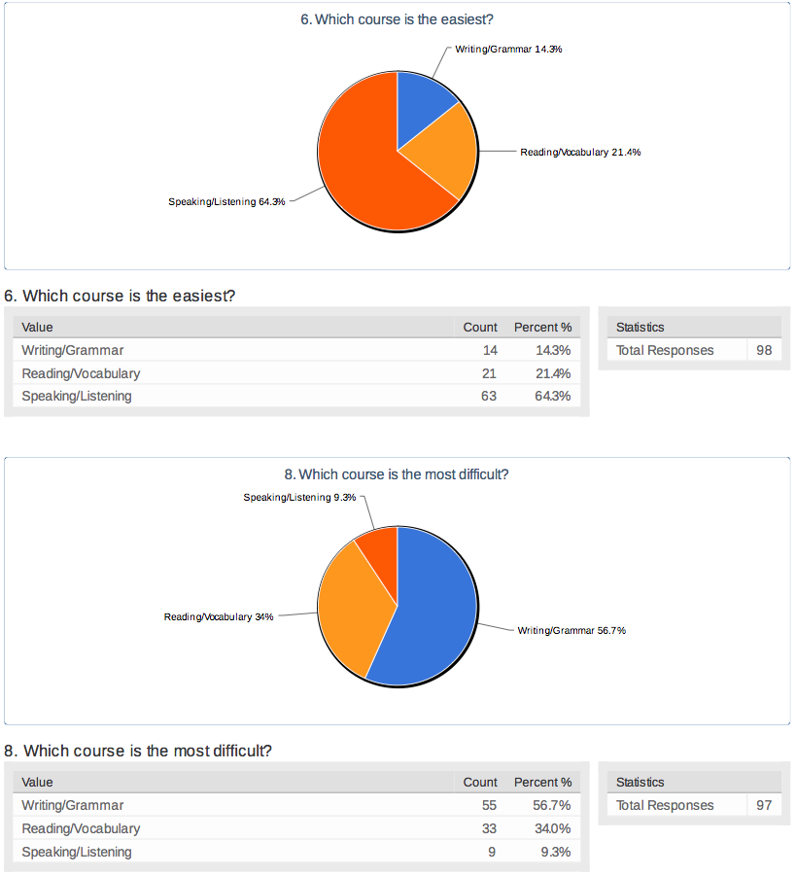
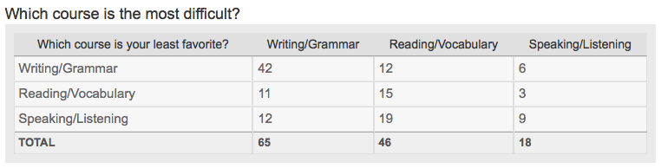

WG is difficult… and it’s my least favorite class.

- It is difficult because of the abilities that the student has to acquire to pass a level. It is also good apart from the difficulty because the teacher make the learning easier.
- It is difficult to fully express ideas in a second language we are learning.
- It is not difficult really, but writing is a skill that needs a long time to master.
- Because I am not creative in writing. I am scientific writer, so I don't like to write something literature

What do you like about your WG Class?

What does a good WG teacher do?

